 | QUOTE/BOOKING FORM  Tel: 0151 648 3871  Mob: 07962061201  mailto:info@funkycampersuk.com  I Do Campers in Association with Funky Campers UK

Date of Wedding:
Ceremony Start Time:
BRIDE’S NAME:
GROOM’S NAME:
CONTACT NAME
CONTACT ADDRESS:
Tel: (Daytime): | Tel: (Evening): |  | Tel: (Mobile): | Email Address:
Vehicle Choice |  | SANDY ◻   BEAU ◻    

Collection Time No.1:
Collection Address No.1:
Postcode:
Occupants Travelling:
Collection Time No.2: (from extra £25)
Collection Address No.2: (if Applicable)
Postcode:
Occupants Travelling:
Ceremony Start Time:
Ceremony Address:
Postcode:
Time of Reception Venue Arrival:
Address of Wedding Reception Venue
Postcode:

Page 1 of 4
Ribbon Colour | Cream   White Ivory    Other
If selecting ‘Other’, please tick to confirm if you are supplying the ribbon of your choice ◻
(To be supplied no less than 1 week prior to Wedding)
Would you like a complimentary bottle of bubbly? Just let us know with a YES or NO! 🥂
Any Special Requests:

Total Cost of Hire Quoted: | £TBA | Deposit to Pay
Deposit Sent – Please Confirm Payment Method:  (Please Make Cheques Payable to J Mrs Williamson) | BACS ◻  CHEQUE ◻  Other ◻ | £100

Additional Notes:

Terms and Conditions of Booking and Hire

This agreement is made between I Do Campers and the person/persons signing this document, the Hirer. Once signed by all parties the agreement becomes legally binding and serves as a contract between the Hirer and I Do Campers.

Hereinafter ‘I Do Campers’ shall be known as The Company and the named person making the booking shall be known as The Hirer. It will be deemed that The Hirer accepts responsibility for every person in his or her party and agrees to the conditions of hire as follows:-

Booking
1. Bookings are valid upon receipt of a completed and signed booking form, terms and conditions, non- refundable deposit (in cleared funds) of £100 or 20% of the total booking value, whichever is the greater and written confirmation from I Do Campers. The final, outstanding balance must be paid 4 weeks prior to the wedding date. Should a booking be made within 4 weeks (28 days) of the booked event date, immediate full and final payment of the booking value will be required to secure your booking.

2. The Company reserves the right to accept alternative bookings if this amount is not paid by the due date.

3. We are able to accept payment by cash (we do not advise sending cash by post), cheque or via bank transfer.

4. In the unlikely event of your chosen camper vans being unavailable for your wedding due to mechanical breakdown or involvement in an accident and an alternative camper van is unavailable, we will refund all money (including deposit). The deposit is otherwise non refundable.

5. Once a booking is made and confirmed, the price quoted will not be changed unless the Hirer wishes to make alterations to the booking. Examples of this are extra requests such as change of venue or additional pick up points incurring extra mileage, extra flowers/decorations.

6. I Do Campers reserve the right to raise the price quoted on our website at any time. However, this will not affect existing quotes and agreements/bookings.

Cancellations
7. In the event of cancellation by the hirer, the deposit will be forfeited. For cancellations less than 4 weeks prior to the wedding date the full amount will be payable.

Unforeseen Circumstances
8. I Do Campers cannot accept responsibility for adverse weather conditions, or acts by other persons that may impact on the hire period. This includes traffic congestion, en route to and between destinations, as this is out of our control. We will do all we can to maintain appropriate standards despites difficulties not occasioned by ourselves.
Page 2 of 4

Your Booking
9. A quote will be given in writing and will be based upon the information provided by the hirer. If we are informed of further pick-ups or other arrangements at a later date I Do Campers reserves the right to make changes to the original quote and charge extra accordingly.

10. Distances that exceed a 40 mile round trip from our base will incur extra mileage. This is charged at £3.00 per mile and is calculated using Google Maps. Mileage costs will be included in the quote.

11. The vehicle comes dressed with your colour choice of ribbons and bows available from our stock. Fresh flowers or other decorations can be arranged at extra cost or supplied by the Hirer prior to departure from I Do Campers. Please let us know your final requirements at least four weeks prior to the wedding date.

12. We offer a complimentary bottle of prosecco (or alternative) for the bride and groom.

The Vehicle
13. Whilst every effort is afforded to maintain the serviceability of our vehicle(s), responsibility cannot be accepted for mechanical, electrical or material breakdown. In this unlikely event, every effort will be made for the immediate repair to the vehicle. However, if this is not possible a full refund will be paid.

14. The Company reserves the right to substitute vehicles in the event of mechanical failure or other circumstances beyond their control.

15. In the event of conditions mentioned in points 13 and 14 or any other breakdown or accident, no responsibility will be accepted for missed connections and/or functions, however caused.

16. In the event of a breakdown or accident to the vehicle prior to the date of booking, every effort will be made to supply an alternative vehicle(s) at I Do Campers discretion. If this is not acceptable to The Hirer a refund will be made of money paid.

Food and Drink
17. The consumption of food and drink in the vehicles is not permitted unless authorised by I Do Campers.

Smoking
18. No smoking is permitted in the vehicles at any time.

Vehicle Damage
19a. The hirer shall be fully responsible and liable for any damage caused both inside and outside the vehicles by themselves or any member of their party howsoever caused. This includes incitement to ANY third party, which results in damage to the vehicle of its contents. The Hirer will agree to be liable for the total cost of the repair and I Do Campers will determine the location of the repairer. In addition, The Hirer will be liable to pay to I Do Campers a fixed daily rate (determined by the Company) whilst the vehicle is out of commission for such repairs, plus any further incurred losses, i.e. lost bookings.

19b. The driver can refuse at any time to position/drive the camper van into an environment, which they feel may damage the vehicle. For example, a beach, field, unsuitable road surface, obstructions that may cause damage such as flood, trees, mud or snow.

Personal Possessions
20. I Do Campers take no responsibility for the personal possessions of the Hirer or any member of their party, left in the vehicles. Please ensure that all possessions are removed at the end of the rental period.

Page 3 of 4

Behaviour
21. I Do Campers reserves the right to refuse entry to vehicles and can refuse to continue the journey if any person(s) behave in a manner that may be detrimental to any other person or the vehicle and its contents. In this event no refund of monies paid will be given.

22. A £100.00 valeting cost will be charged if the vehicle requires additional cleaning due to food or drink spillages or illness.

Seat Belts
23. Wherever possible seat belts must be worn. Camper vans are fitted with lap belts in the rear and 3-point seat belts in the front. Due to UK seat belt law we regret that we are unable to transport children under the age of 3 were inertia belts are required.

Photographs
24. I Do Campers may take photographs of your wedding to be used on our website, Facebook page or promotional material. If the hirer does not consent to this please inform us at the time of booking.

Personal Data
25. When you book the vehicle we will collect personal data from you, such as name, address, email address and telephone number. We will not use your personal data for any other reason.

26. I Do Campers reserves the right, at its sole discretion, to change, modify, add or remove any portion of these terms in whole or in part, at any time. Changes to the terms will be effective when notice of such changes is posted.

I (The Hirer) confirm that I have read and agree to the above Terms & Conditions for the rental of wedding car services at a total of:

£……………….. SIGNED: …………………………………………...……….DATE: ……………………

PRINT NAME: …………………………………………………………

**Please note by sending this quote you accept our term and conditions**

Please sign and email to : info@funkycampersuk.com or post to: I Do Campers, 28 Heywood Boulevard, Thingwall, Wirral CH61 3XF

Our Bank Details are:
Halifax (Personal Account)
Name: D M Williamson
Sort code: 11-52-64
Account: 10437260



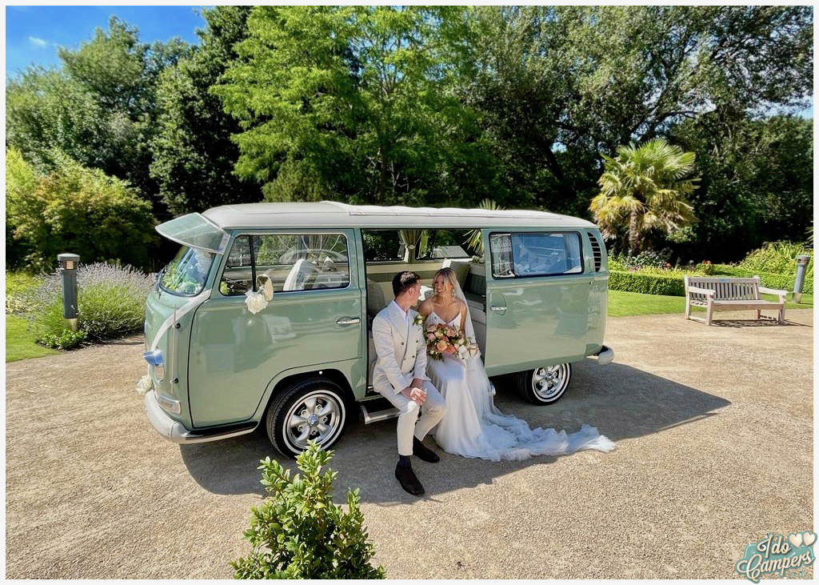
BEAU
Bay Window in
Sage Green
SANDY
Split Screen
In Ivory over Gold

Page 4 of 4

